CaseManagement_CreationOfCase_Instance23_03-Aug-2018_07-55-10_AM_MouseClickActionMoveToElementByxpathimgaltServiceparentspan.png

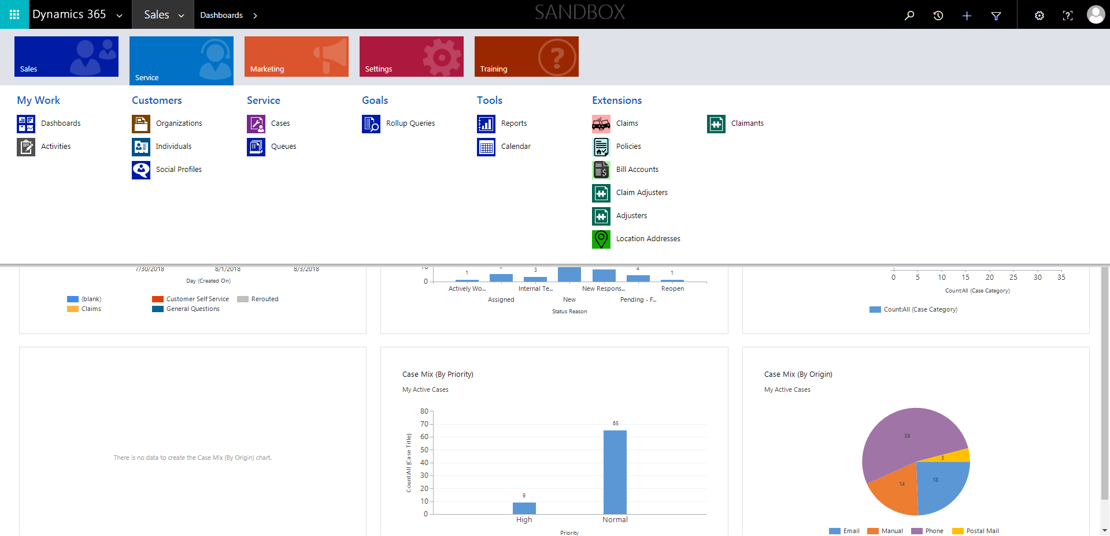

CaseManagement_CreationOfCase_Instance23_03-Aug-2018_07-55-03_AM_SingleSignOn.png

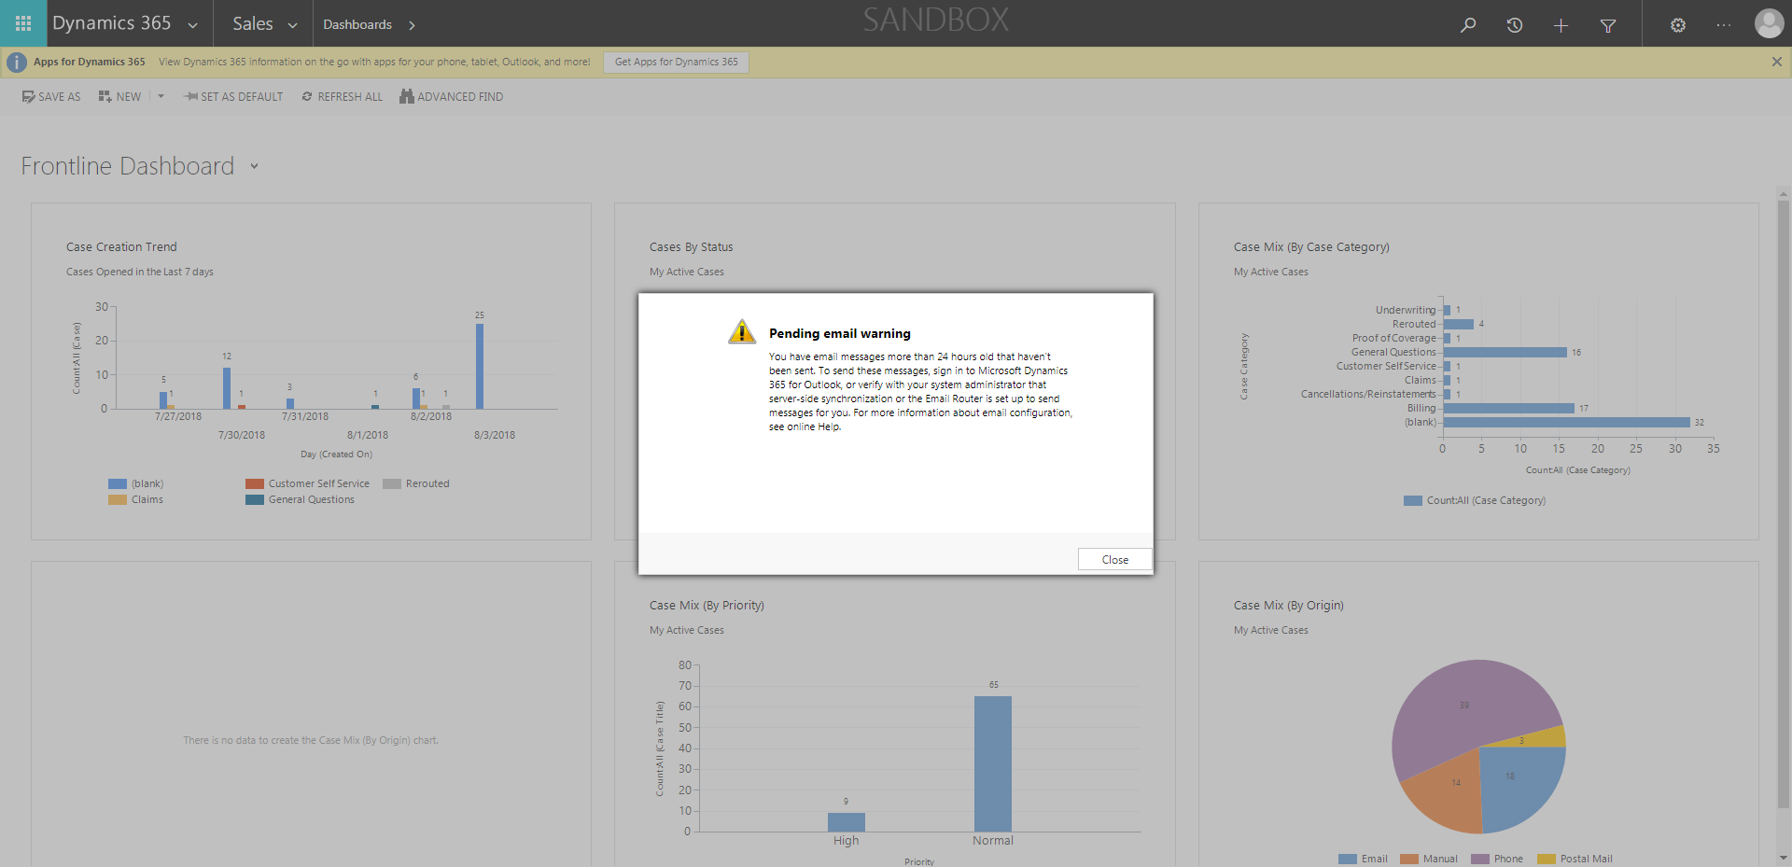

CaseManagement_CreationOfCase_Instance23_03-Aug-2018_07-54-41_AM_EnterTextAction.png

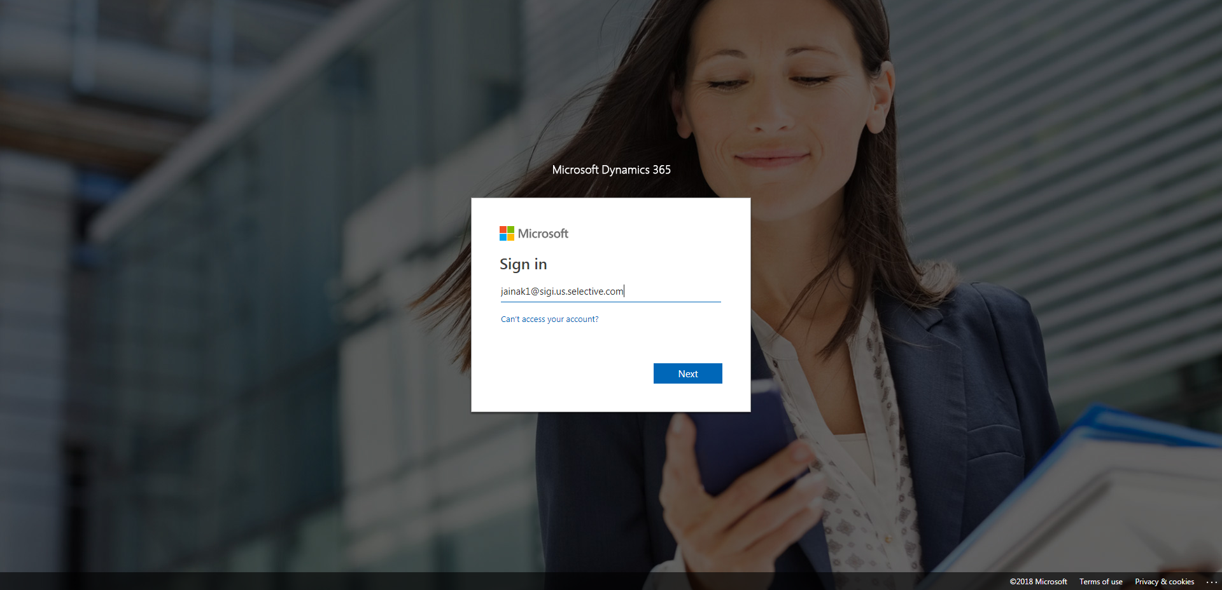

CaseManagement_CreationOfCase_Instance23_03-Aug-2018_07-55-09_AM_MouseClickActionMoveToElementBycssSelectorspanTabSFA.png

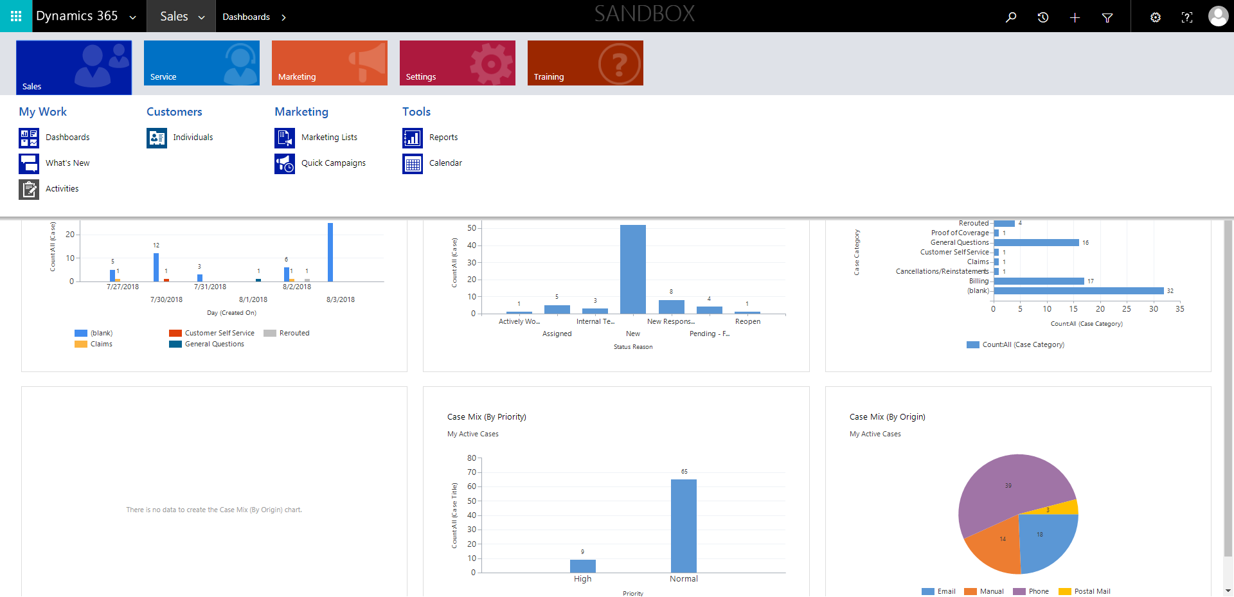

CaseManagement_CreationOfCase_Instance23_03-Aug-2018_07-54-42_AM_MouseClickActiononStaleElement.png

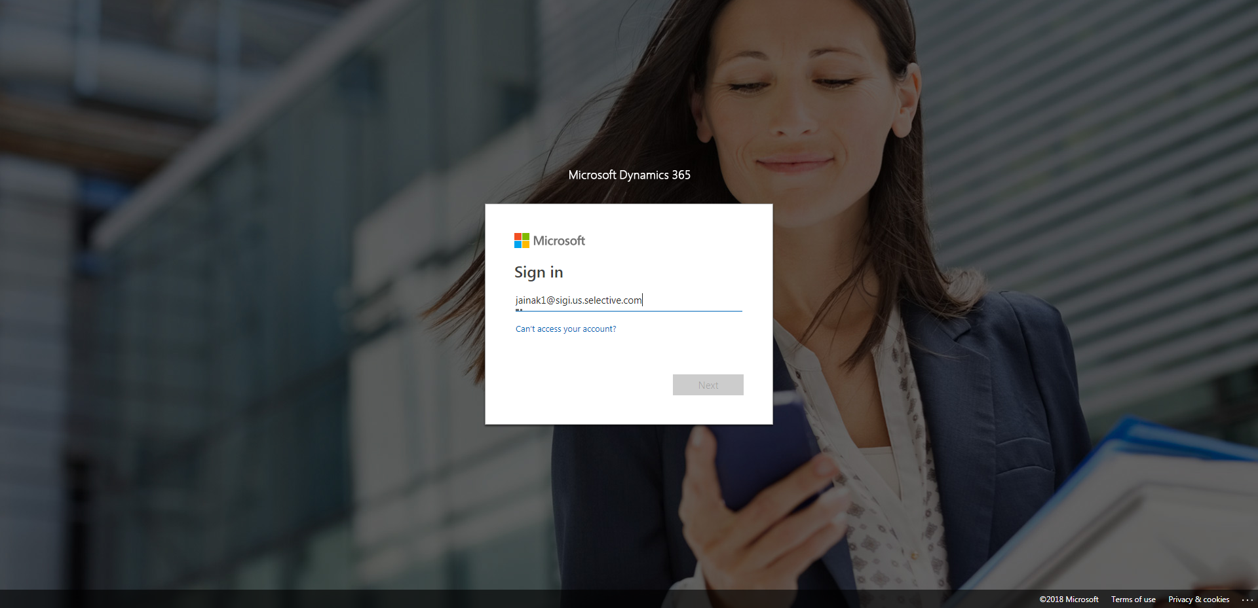

CaseManagement_CreationOfCase_Instance23_03-Aug-2018_07-54-39_AM_MouseClickActiononStaleElement.png

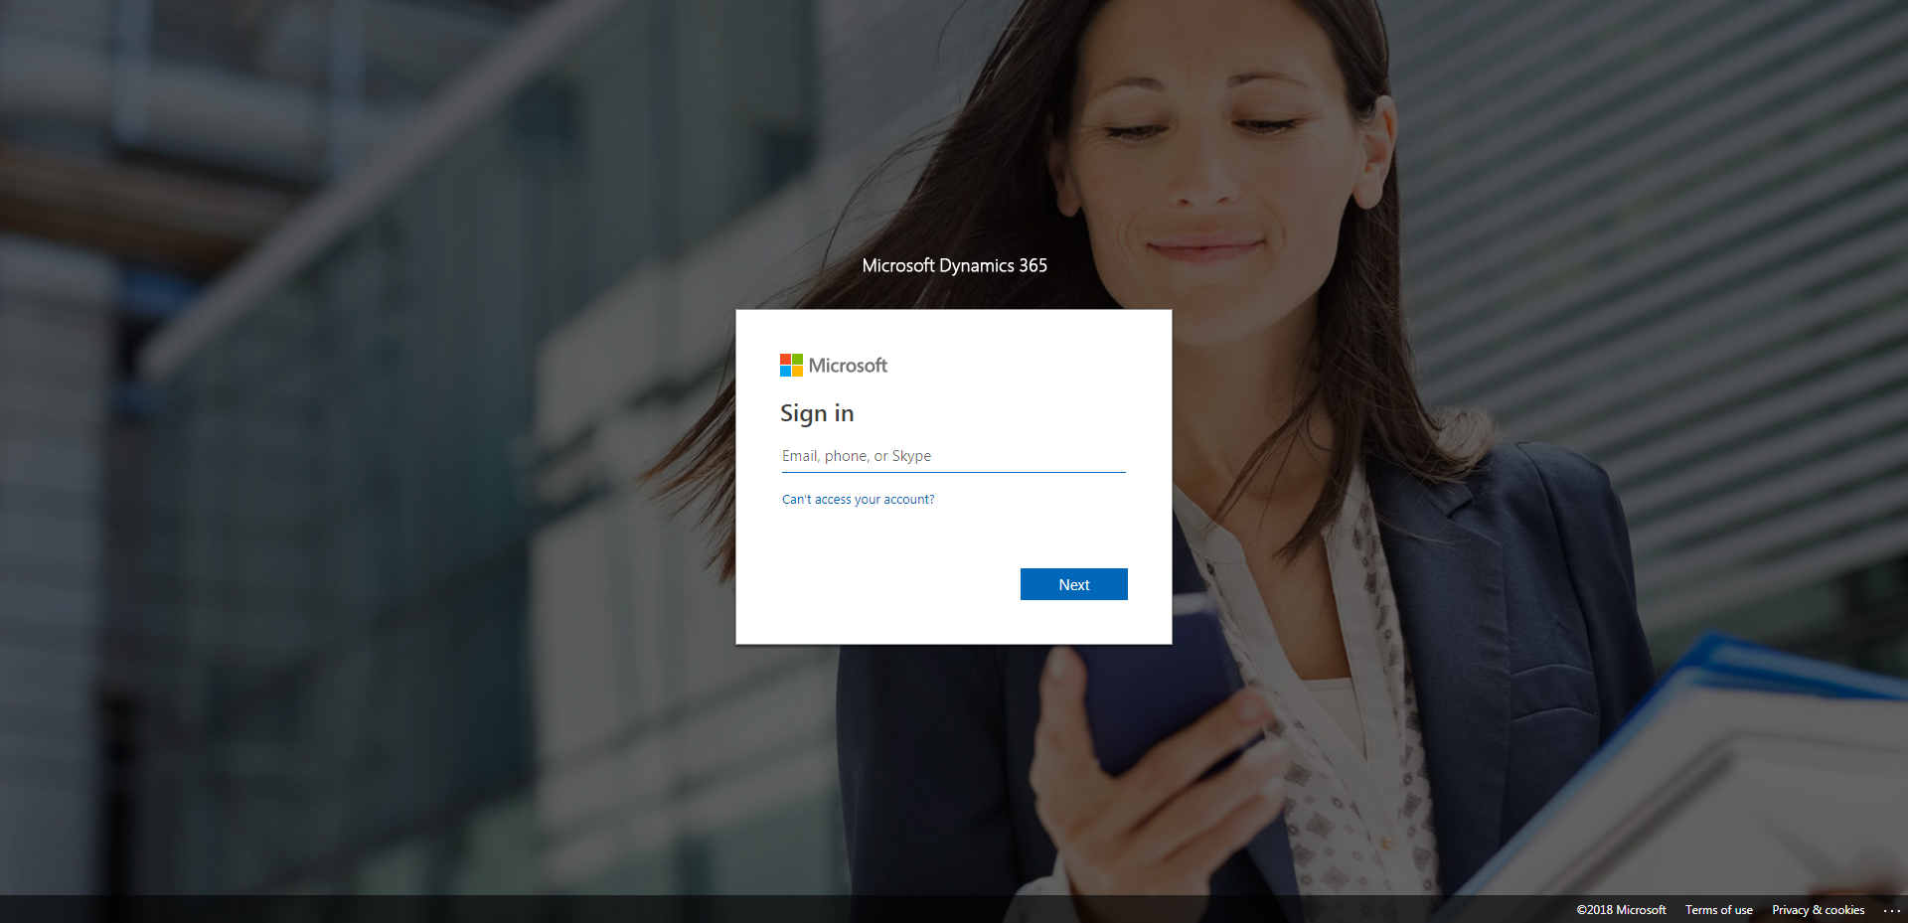

CaseManagement_CreationOfCase_Instance23_03-Aug-2018_07-55-05_AM_SingleSignOn.png

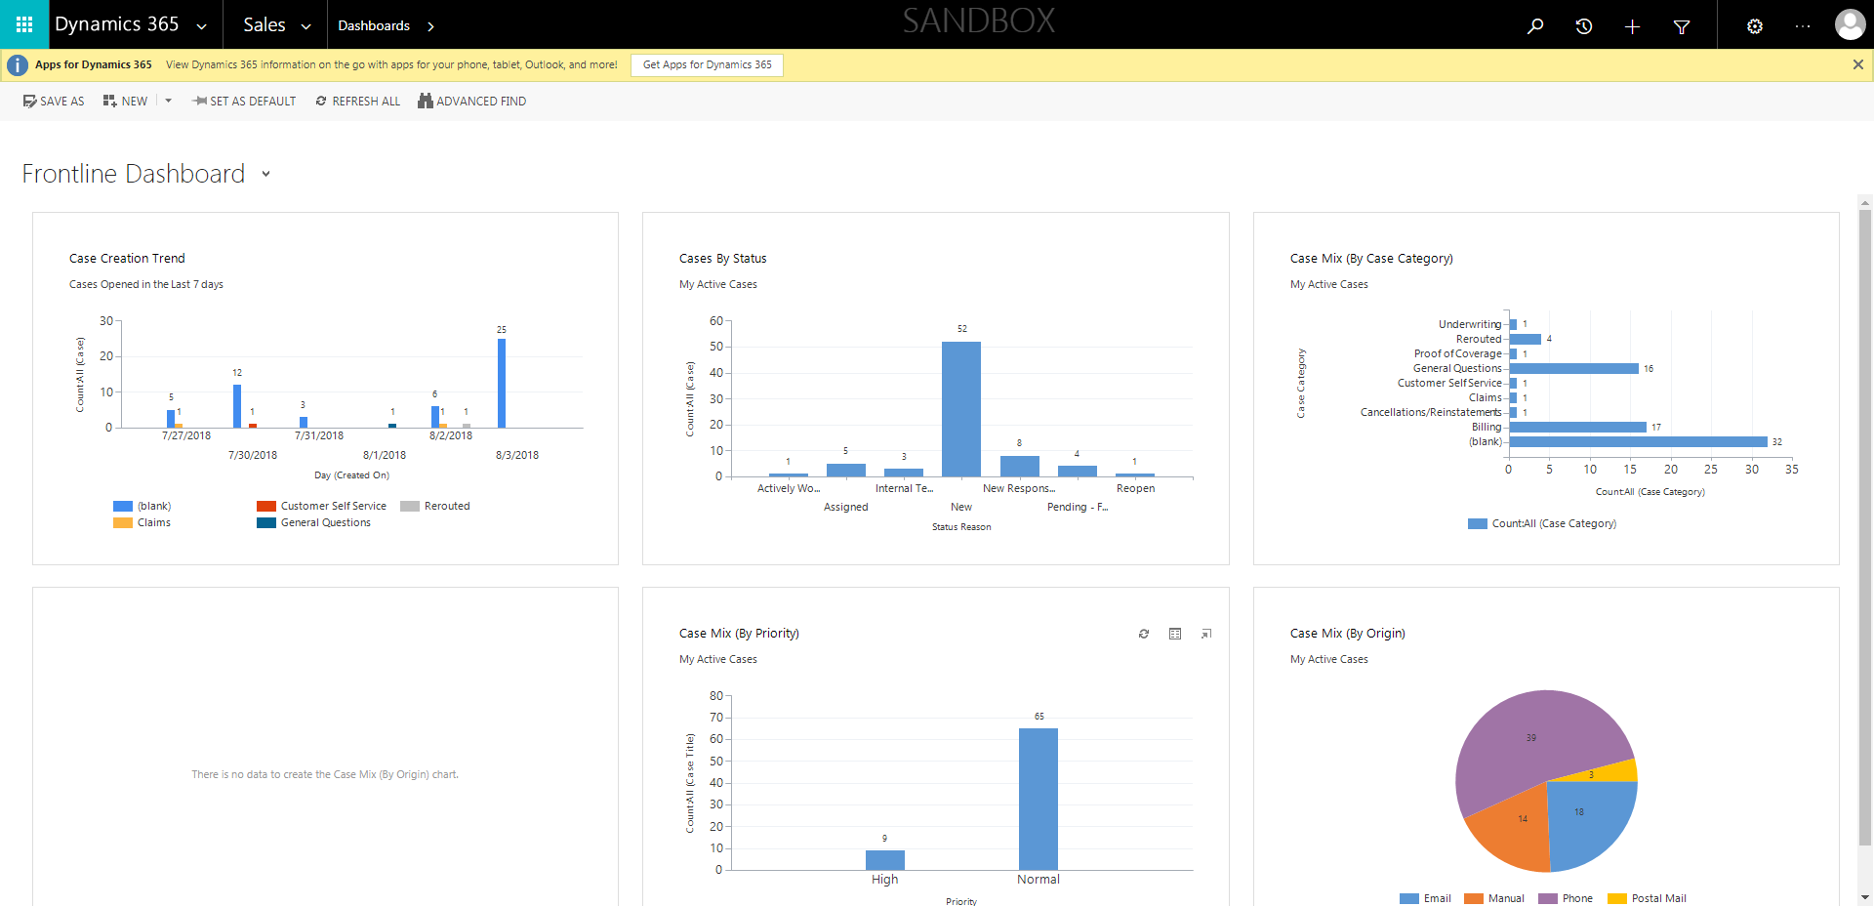

CaseManagement_CreationOfCase_Instance23_03-Aug-2018_07-55-11_AM_MouseClickActionMoveToElementBycssSelectoranavcases.png

